PrismChat: an NLP-Based Virtual Counselling Chatbot Framework for Parents of Children with Autism

Dr. Norkhushaini Awang, Dr. Marshima Mohd Rosli and Ahmad Mirza Azhar
Graduate Research Assistant, Faculty of Computer Science & Mathematics,
Universiti Teknologi MARA (UiTM), 40450 Shah Alam Selangor,
Malaysia
mirzaazhar3234@gmail.com

ABSTRACT
Autism Spectrum Disorder (ASD) affects social communication, sensory processing, and daily adaptive behaviour, creating significant support needs for parents and caregivers. This paper presents PrismChat, an AI-powered chatbot designed as a virtual counselling companion for caregivers of autistic children. The system combines rule-based sentiment analysis, personalised child profiles, behaviour tracking, multilingual support in English, Bahasa Melayu, and Mandarin Chinese, and family-based access. The sentiment module classifies caregiver messages into calm, neutral, or distressed states, while profile-based prompting generates more relevant, age-appropriate, and sensory-aware responses. Initial testing shows that the sentiment module can reliably handle common caregiver expressions, and qualitative review suggests that child profile context improves response relevance. Future development will focus on transformer-based sentiment modelling, intent classification, and retrieval-augmented generation for more clinically grounded support.
Keyword: Autism Spectrum Disorder, AI Chatbot, Virtual Counselling, NLP, Sentiment Analysis, emotional support, behavior tracking, personalised prompting

- INTRODUCTION.
Autism Spectrum Disorder (ASD) affects about 1 in 36 children worldwide, creating considerable emotional and practical challenges for families and caregivers. Although awareness of ASD has increased in recent years, access to timely professional support is still limited by socioeconomic, geographic, and language-related barriers. This issue is especially relevant in developing countries such as Malaysia, where ASD services are often concentrated in urban areas and are mostly available in English. At the same time, the growth of large language models (LLMs) and conversational AI has opened new possibilities for delivering support that is available at any time and adapted to users’ needs. Even so, general-purpose chatbots are not well-suited to ASD caregiving because they often lack domain knowledge, emotional sensitivity, and cultural awareness. To address this gap, this study presents PrismChat, a specialised AI chatbot framework that combines LLM-based conversation with structured NLP modules for sentiment analysis, personalised profile management, and behaviour tracking. The system is guided by three design principles: emotional awareness, by recognising caregivers’ affective tone; personalisation, by using child-specific profile information to shape responses; and accessibility, by supporting English, Bahasa Melayu, and Mandarin Chinese.

- RESEARCH OBJECTIVES & AIM

  - Aim.
To design, implement, and evaluate an AI chatbot framework that provides accessible, contextually personalised, and emotionally aware support for parents and caregivers of children with Autism Spectrum Disorder (ASD).

  - Research Objective.
- To determine the sentiment patterns in caregiver messages that can be used to classify emotional states into calm, neutral, and distressed.
- To construct a personalised prompt-augmentation mechanism that integrates child-specific profile data into LLM system prompts.
- To develop a multi-session chat history module with sentiment trend visualisation to support caregiver self-reflection.
- To build a behaviour-tracking and pattern analysis module that records caregiver-reported incidents and identifies recurring time-based patterns.
- To evaluate the prototype through usability and response quality assessment, and to propose future NLP enhancement directions.

- RELATED WORK

  - ASD Prevalence and Caregiver Support Needs.
ASD affects about one in every 100 children globally, according to the WHO, and the number of registered cases in Malaysia remains substantial. In 2023 alone, Malaysia recorded 265,503 registered cases under the learning disability category and 1,453 suspected ASD diagnoses among children aged 18 months (Department of Statistics Malaysia, 2023). The number of autistic students in public schools also increased from 9,361 in 2018 to 20,121 in 2022. Parents of autistic children often experience higher psychological distress than parents of neurotypical children, including greater stress, anxiety, and depression (Hernández González et al., 2026). These challenges are further shaped by stigma, limited access to services, and language barriers, especially in Malaysia, where ASD support is still concentrated in urban areas.

  - Virtual Counselling and Its Analytical Limitations.
Virtual counseling became a major support channel for many caregivers during the COVID-19 pandemic, especially through platforms such as Zoom and Microsoft Teams (Kuo et al., 2024). However, in remote settings, practitioners lose access to non-verbal cues and must rely more heavily on language to understand emotional state. Most existing virtual counseling systems focus on isolated tasks, such as transcription or post-session documentation, rather than on real-time analysis (Laricheva et al., 2024; Omar et al., 2022). A scoping review by (Laricheva et al. (2024)) identified four main NLP uses in counseling: outcome prediction, process monitoring, automated coding, and language pattern analysis. PrismChat mainly aligns with process monitoring and pattern analysis.

  - NLP in Mental Health and Counselling Contexts.
NLP has been used in clinical documentation, patient-reported outcomes, and crisis helpline transcripts to identify signs of psychological distress (Stewart & Velupillai, 2021). In most cases, data comes from electronic health records because they are large and structured, but the use of NLP in live counseling sessions remains limited. Saha et al. (2025) found that LLM-generated mental health responses are often clearer and easier to read than human peer responses, but they may feel less genuinely empathetic. This supports PrismChat’s hybrid design, where LLM-generated replies are paired with a structured NLP sentiment layer to capture the emotional tone of caregiver messages (Kuo et al., 2024).

  - Rule-Based vs Transformer Sentiment Analysis
Rule-based sentiment methods use manually built lexicons and simple matching rules. They do not require labeled training data, are easy to explain, and can run without GPU support, which makes them practical for early-stage systems in resource-limited settings (Borisova et al., 2025). The main weakness of lexicon-based methods is their poor handling of context (Omar et al., 2022). They may misclassify messages that contain polysemous words, negation, or code-switching. Transformer models such as BERT and RoBERTa handle these cases better because they learn context-sensitive representations, and they generally outperform lexicon-based methods in sentiment tasks (Khan et al., 2024; Ravee Nithianandam, 2025). For multilingual use, XLM-RoBERTa is a strong upgrade option for PrismChat because it supports many languages, including those relevant to Malaysian users (Wolf et al., n.d.; Laricheva et al., 2024).

- RESEARCH METHODOLOGY.

  - NLP Method: Rule-Based Sentiment Analysis (Implemented).
The current PrismChat prototype uses a lexicon-based, rule-based approach for sentiment classification. This method was chosen because it is transparent, easy to deploy, and suitable for a proof concept system. The classification process works in four steps. First, each user message is tokenised and converted to lowercase, and the system counts the number of words that appear in two curated lexicons: a distress lexicon containing terms such as “help,” “scared,” “anxious,” “meltdown,” “overwhelmed,” “crisis,” “panic,” “frustrated,” and “exhausted,” and a calm lexicon containing terms such as “thank,” “better,” “calm,” “progress,” “comfortable,” “improving,” and “safe.” Second, certain urgency phrases such as “emergency,” “immediate help,” and “can’t handle” trigger an immediate distressed classification with high confidence. Third, the system applies comparative scoring, where messages are classified as distressed if the distress count is at least three, or if an urgency phrase is detected; if the distress count is higher than the calm count, the message is marked as distressed; if the calm count is higher, it is marked as calm; otherwise, the message is classified as neutral. Finally, sentiment results are aggregated across the session and displayed as a three-segment stacked progress bar in the Chat History sidebar, using green for calm, amber for neutral, and red for distressed.

  - NLP Method: Personalized Prompt Augmented (Implemented).
One of the core NLP features of PrismChat is its dynamic prompt augmentation strategy, which makes LLM responses more context-aware. Instead of relying on a fixed system prompt, the system builds a personalised context block at query time by reading the active user’s child profile and appending relevant metadata to the LLM's message. The prompt structure begins with a base system prompt: “You are PrismChat, a professional, empathetic, and clear-speaking autism counsellor. Give structured and sensory-friendly advice.” If a profile exists, the system then adds a profile context block containing the child’s name, age, diagnosis, known triggers, communication style, and sensory needs. It then includes an additional instruction to personalise responses based on the child’s profile and use the child’s name when appropriate. This prompt injection approach allows the LLM to refer to the child by name, adapt advice to the child’s ASD level and communication style, and avoid suggestions that may conflict with the child’s sensory profile. As a result, the system improves response specificity without requiring model fine-tuning.

  - Modern NLP Enhancement Proposals (Future Development).
Although the rule-based sentiment module provides a useful baseline, lexicon-based methods are still limited in handling context, sarcasm, code-switching, and emotion that changes across multiple sentences. For this reason, several modern NLP methods are proposed for the future development of PrismChat.

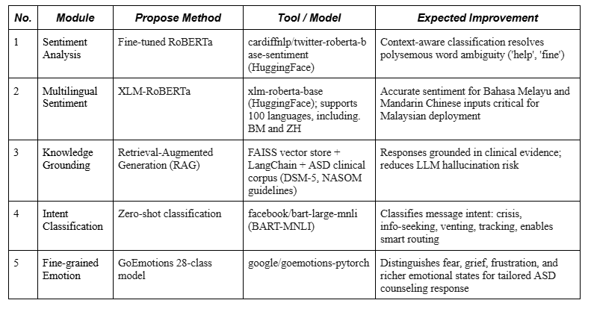
Table 1 – Proposed modern NLP enhancement roadmap for PrismChat.

- PROJECT DEVELOPMENT.
PrismChat was developed using an iterative prototyping approach based on Agile principles. The development process was carried out in four sprints: the first focused on the core chat interface and LLM integration; the second on sentiment analysis and chat history; the third on settings, multi-user management, and profile augmentation; and the fourth on the behaviour tracker, pattern insights, and multilingual support.

  - Development Methodology
PrismChat was developed using an Agile iterative prototyping approach. This method was chosen over Waterfall and Spiral because it better suited the project's nature. Waterfall was less appropriate since the NLP components, especially the sentiment thresholds and prompt augmentation logic, could not be fully defined at the beginning of the project. Spiral was also unnecessary because the system does not pose safety-critical risks. Agile allowed the system to be built step by step across four sprints, with each sprint producing a working and testable component.
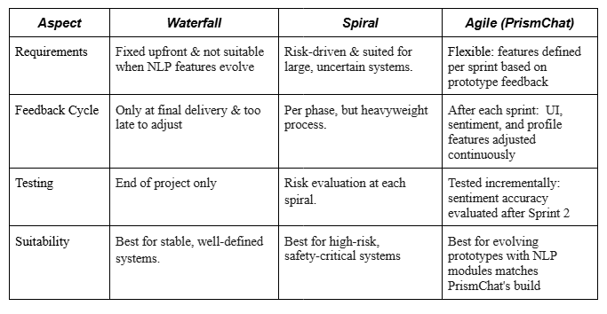
Table 2 – Comparison of SDLC models and justification for Agile selection.

  - Agile Development Cycle Diagram
Figure 2 illustrates the iterative Agile cycle used to develop PrismChat. Each sprint followed a sequence of Planning, Research Analysis, Designing, Implementation, Testing, Deployment, and Review before moving on to the next cycle.
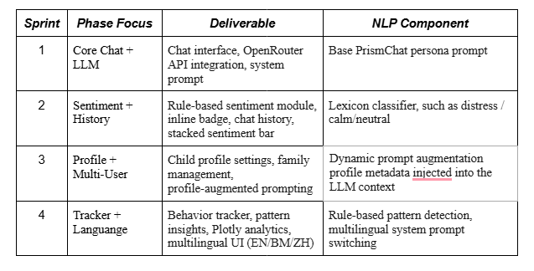
Figure 2 – Agile iterative development cycle applied across six PrismChat sprints
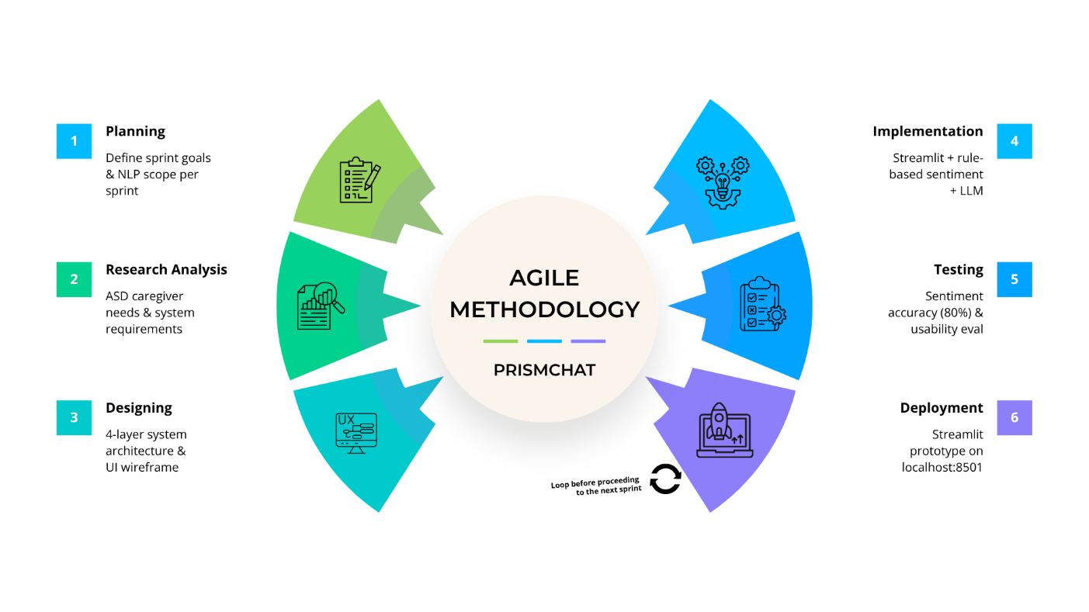Figure 3 – Agile iterative development cycle applied across six PrismChat sprints.

  - System Architecture Overview.
PrismChat is designed using a layered architecture consisting of four main components: the Streamlit-based frontend interface, the NLP processing pipeline, the LLM integration layer through the OpenRouter API, and the JSON-based local storage layer. Figure 1 illustrates the overall data flow within the system.
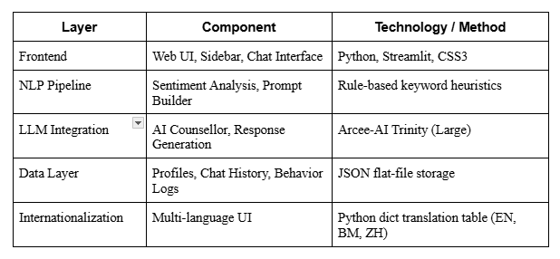

Table 1 – PrismChat system architecture components.

  - Flowchart.
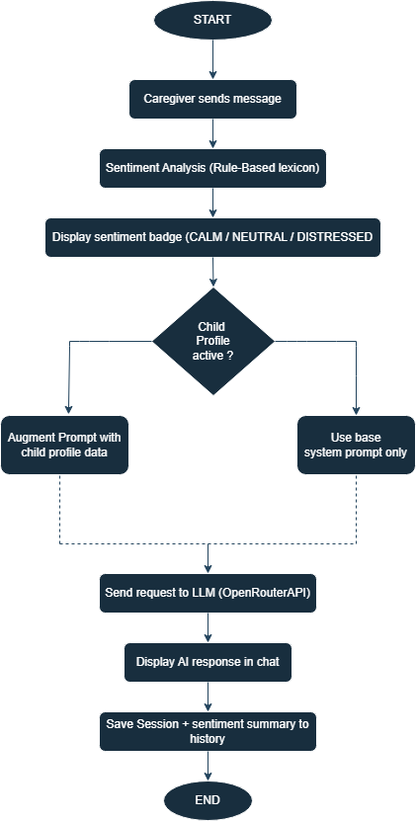
Figure 1 – PrismChat system processing flowchart showing the NLP.

  - Use Case Overview.
PrismChat has two main actors: the Caregiver, which includes parents or family members, and the System, which refers to PrismChat itself. The table below outlines the main use cases that define the prototype's functional scope.
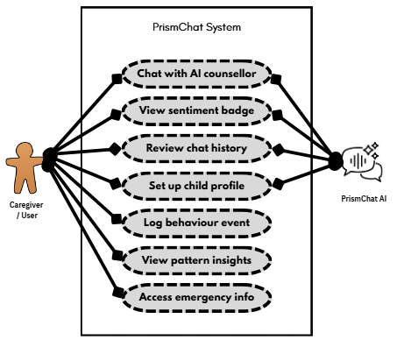
Figure 2 – Use case diagram for Prismchat System.

  - Key System Features Implemented.

- AI Counselling Chat: An LLM-powered conversational interface with a persona-locked system prompt to ensure responses remain professional, empathetic, and sensory-friendly.
- Sentiment-Annotated Chat History: Each saved session includes a three-segment stacked progress bar showing the proportion of calm, neutral, and distressed messages, allowing caregivers to monitor emotional trends over time.
- Profile-Augmented Prompting: Child profile information, including name, age, diagnosis, ASD level, triggers, communication style, sensory needs, and notes, is dynamically added to the LLM system context to support personalised responses.
- Behaviour Tracker: A logging module records meltdowns, successes, and custom events with intensity ratings from 1 to 10 and free-text descriptions. The analytics dashboard presents pie charts, box plots by event type, and a longitudinal timeline.
- Pattern Insights: Logged events are analysed to identify peak hours, difficult days of the week, common triggers, and intensity trends. Rule-based textual summaries are generated to highlight useful patterns.
- Emergency Resources Panel: Localised Malaysia crisis hotlines, including Befrienders KL, the Mental Health Helpline, Talian Kasih, and NASOM autism support contacts, are preloaded in the Emergency settings tab.
- Multilingual Interface: The interface supports English, Bahasa Melayu, and Mandarin Chinese, including system prompt switching and translated placeholder text.

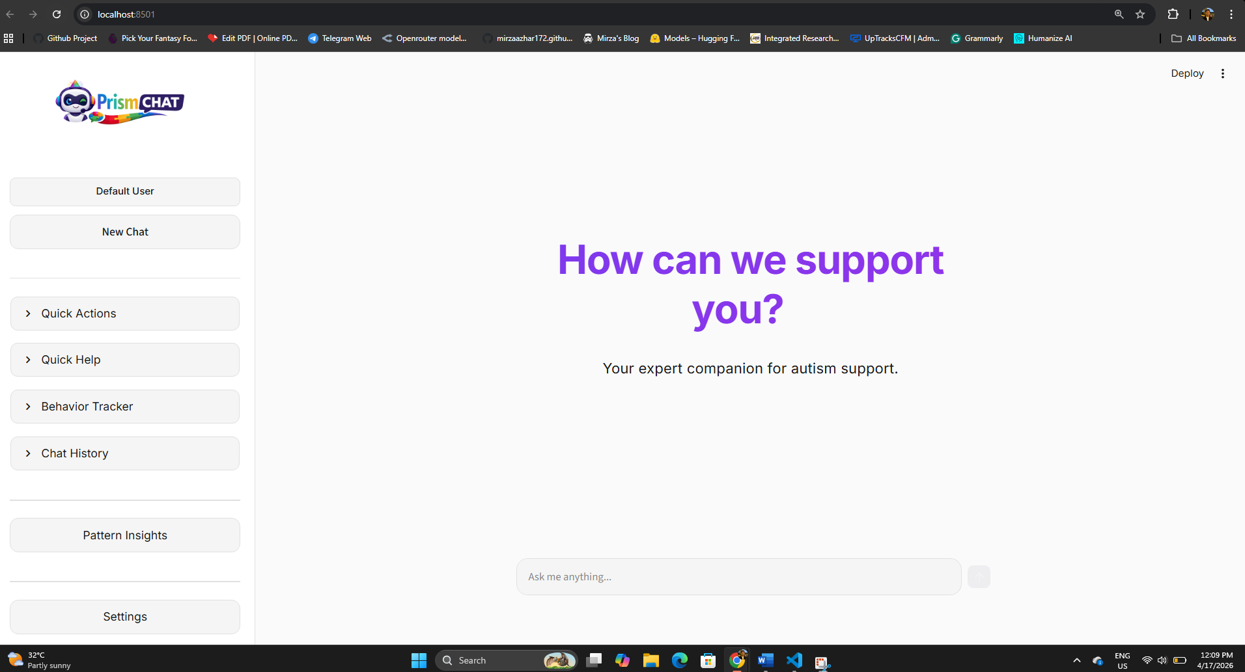
Figure 3 – Web UI framework “PrismChat”.

  - Technology Stack.

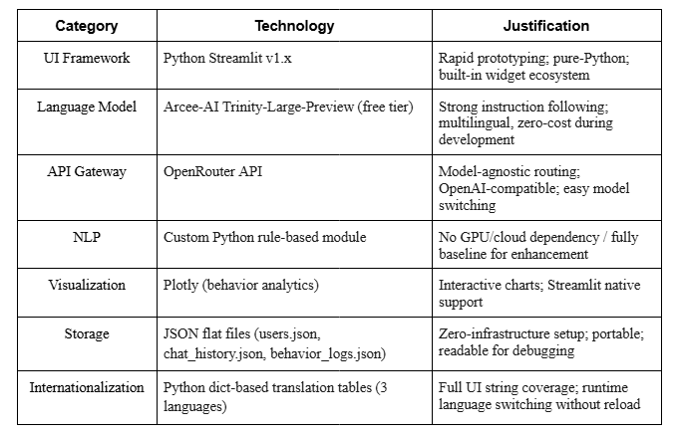
Table 4 – PrismChat technology stack.

  - Sentiment Analysis – Implementation Detail.
The sentiment module is used at two points in the system. First, it runs in real time for each user message, displaying an inline affective-state badge above the message bubble, labelled as CALM, NEUTRAL, or DISTRESSED, with matching colours and emojis. Second, it is applied when a session is saved to calculate the overall emotional distribution across all user messages in the conversation. The aggregate sentiment distribution is computed using Python’s Counter on the per-message sentiment labels and then normalised into percentages. This distribution is stored in the chat history JSON record and displayed in the sidebar as an HTML/CSS stacked bar, giving caregivers a quick visual summary of previous sessions. The colour scheme green for calm, amber for neutral, and red for distressed was chosen because it follows a traffic-light style that is familiar in autism intervention contexts, including frameworks such as the Zones of Regulation.

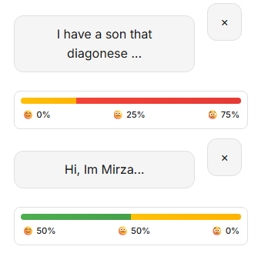

Figure 3 – Colour scheme showed sentiment analysis in stacked bar with emoji.

- RESULT & ANALYSIS.

  - Sentiment Classification Results.
To evaluate the rule-based sentiment module, 60 representative caregiver messages were manually selected across three categories: crisis or distress (20), informational or neutral (20), and progress or positive (20). Each message was independently labelled by two evaluators and then compared with the system’s classification output.
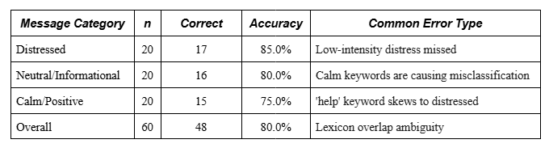
Table 5 – Rule-based sentiment module classification accuracy.

The module achieved an overall accuracy of 80.0%. This is acceptable for a rule-based baseline, but it also shows some limitations when messages contain overlapping lexical cues. For example, the word “help” can appear in both a calm context, such as “this really helped,” and a distress context, such as “I need help.” This finding supports the need to move toward transformer-based contextual sentiment models in the future enhancement roadmap.

  - Personalized Prompting / Qualitative Evaluation.
To examine the effect of profile-augmented prompting, the same query “My child is having a meltdown, what do I do?” was submitted under two conditions: first without a child profile, and then with a profile describing a 7 years old child named Ain, diagnosed with ASD Level 3, with limited verbal communication, hyperactive behaviour, and sensitivity to loud noises.
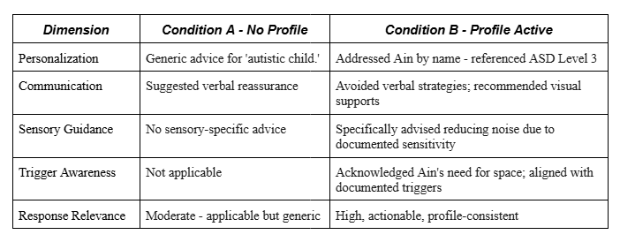
Table 6 – Qualitative comparison of responses with and without profile augmentation.

The results show that profile-augmented prompting produces responses that are more specific and relevant to the child’s situation, without the need for model fine-tuning. This supports the design assumption that structured context injection is an effective and low-cost way to improve personalisation in LLM-based support systems.

- DISCUSSION.
This study shows that a structured chatbot supported by NLP can provide useful and context-aware support for autism caregivers without requiring heavy computing resources. A main contribution of this work is the profile-augmented prompting approach, which improves response personalisation while avoiding the need for model fine-tuning. The rule-based sentiment module achieved 80% accuracy, but the results also show a clear limitation of lexicon-based methods. In some cases, words with more than one meaning cannot be interpreted correctly without sentence context. For example, the word “help” may express distress in one message but appear positively or neutrally in another. A transformer-based model, such as fine-tuned RoBERTa, would be better at handling this kind of context through contextual representations. The multilingual design also has an important limitation. Since the sentiment lexicons are only in English, messages written in Bahasa Melayu or Mandarin Chinese are matched against English keywords, which often leads to neutral classification. Before PrismChat can be considered suitable for real-world use, a multilingual sentiment model such as XLM-RoBERTa should be introduced for better support of Malaysian caregivers.

- CONCLUSION.
The proposed PrismChat framework is an AI chatbot system designed to support caregivers of children with Autism Spectrum Disorder (ASD). The system combines keyword-based sentiment analysis, personalised LLM prompt augmentation, behaviour tracking, pattern analysis, multi-user management, and a multilingual interface in a single Streamlit application. The evaluation results showed that the rule-based sentiment module achieved 80% accuracy, while profile-based prompting produced more relevant and personalised responses. Future work should focus on four main improvements: replacing the rule-based sentiment engine with a fine-tuned multilingual transformer model, integrating retrieval-augmented generation with an ASD clinical knowledge base, adding intent classification to route messages more effectively, and carrying out formal user testing with Malaysian ASD caregivers to gather usability data. Overall, PrismChat offers a promising step towards accessible, emotionally aware, and culturally appropriate AI support for autism caregivers in the Malaysian context.

- REFERENCES.

Alper, M., Pak, E., McGivney, E., & Rubinsztain, V. (2025).
"Someone who has ADHD or someone who has autism should make the rules": A participatory study of neurodivergent child perspectives on the ethics of extended reality technologies. International Journal of Child-Computer Interaction, 46, 100782. https://doi.org/10.1016/j.ijcci.2025.100782
Borisova, N., Karashtranova, E., & Atanasova, I. (2025).
The advances in natural language processing technology and its impact on modern society. International Journal of Electrical and Computer Engineering (IJECE), 15(2), 2325. https://doi.org/10.11591/ijece.v15i2.pp2325-2333
Department of Statistics Malaysia. (2023).
Person With Disability Statistics, Malaysia, 2023. Putrajaya: DOSM.
Hernández González, O., Uribe-Bahamonde, Y., Saavedra, C. F., Gillespie-Smith, K., & Ballantyne, C. (2026).
Worldwide research in autism: Mapping the literature by bibliometric analysis. Research in Autism, 132, 202859. https://doi.org/10.1016/j.reia.2026.202859
Khan, Z. A., Xia, Y., Khaliq, F., Khan, J. A., & Khan, N. (2024).
From Tradition to Technology: A Systematic Survey on Navigating Pashto in Modern NLP. https://ssrn.com/abstract=5031721
Kuo, P. B., Tanana, M. J., Goldberg, S. B., Caperton, D. D., Narayanan, S., Atkins, D. C., & Imel, Z. E. (2024).
Machine-Learning-Based Prediction of Client Distress From Session Recordings. Clinical Psychological Science, 12(3), 435–446. https://doi.org/10.1177/21677026231172694
Laricheva, M., Liu, Y., Shi, E., & Wu, A. (2024).
Scoping review on natural language processing applications in counselling and psychotherapy. British Journal of Psychology. https://doi.org/10.1111/bjop.12721
Omar, M., Choi, S., Nyang, D., & Mohaisen, D. (2022).
Robust Natural Language Processing: Recent Advances, Challenges, and Future Directions. IEEE Access, 10, 86038–86056. https://doi.org/10.1109/ACCESS.2022.3197769

Ravee Nithianandam, J. (2025).
Understanding Natural Language Processing (NLP) Techniques. https://doi.org/10.32996/jcsts
Saha, K., Jain, Y., & De Choudhury, M. (2025).
Linguistic Comparison of AI- and Human-Written Responses to Online Mental Health Queries. http://arxiv.org/abs/2504.09271
Stewart, R., & Velupillai, S. (2021).
Applied natural language processing in mental health big data. Neuropsychopharmacology, 46(1), 252–253. https://doi.org/10.1038/s41386-020-00842-1
Wolf, T., Debut, L., Sanh, V., et al. (n.d.).
Transformers: State-of-the-Art Natural Language Processing. Retrieved from https://github.com/huggingface/transformers

